**Job Hunt Web Admin**

**Attention**

**Please be aware that this project was created using Yarn, please follow the project setup guide to properly install and starts using**

**In case you want to use node instead of yarn, please delete *yarn.lock* and then run *npm install***

**Project setup, installing necessary components**

1. Install [NodeJS](https://nodejs.org/en/)

1. After installing, open your command promt or powershell and type *npm* to test if it's run yet

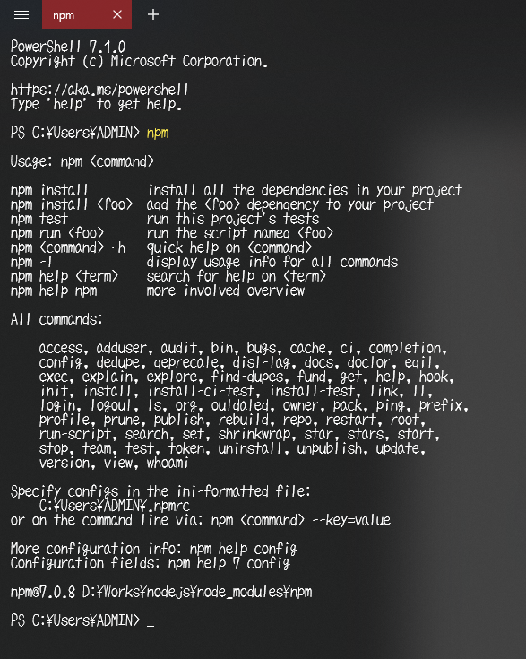

3. Install [Yarn](https://yarnpkg.com/getting-started/install)

1. After installing, open your command promt or powershell and type *yarn* to test if it's run yet

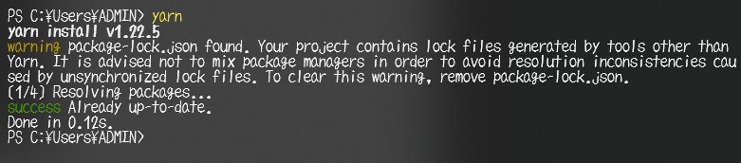

*If both npm and yarn doesn't run in command promt or powershell, then you will have to manually add it to the Path Environment of Windows*

1. Open up CMD, Powershell or using the terminal of VS Code in the project folder and run *yarn install* to install all of the latest packages

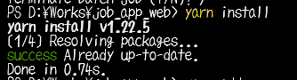

**Update Path Environmen**t

To add Nodejs and Yarn to the Path Environment

1. Locate NodeJS and Yarn installed locations

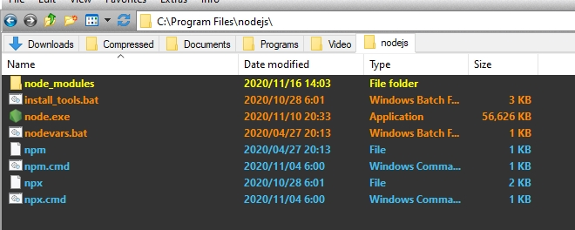

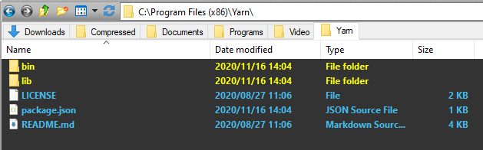

1. Sử dụng chức năng Search của Windows và search Environment

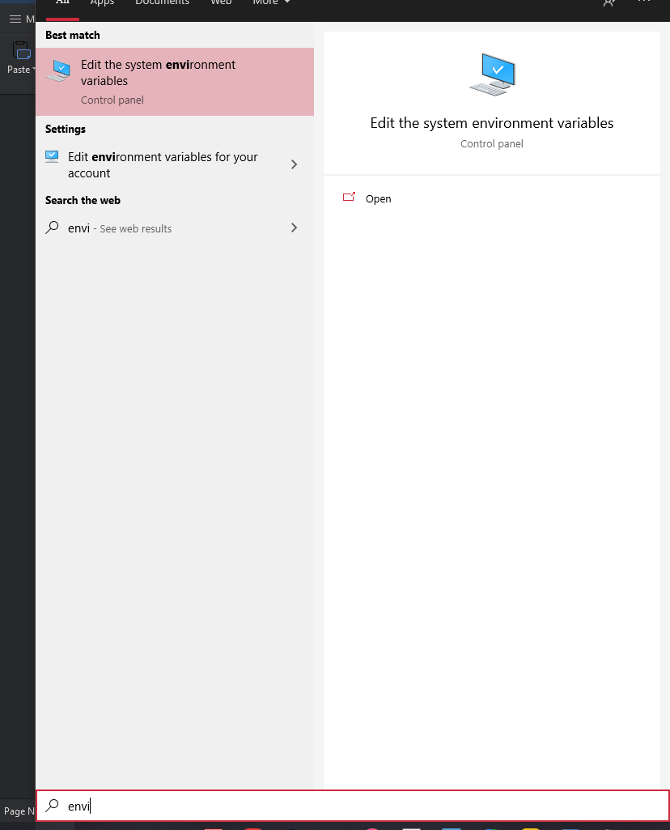

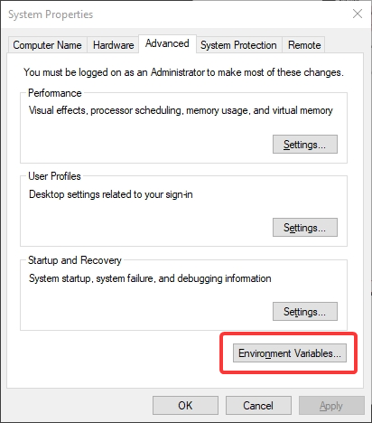

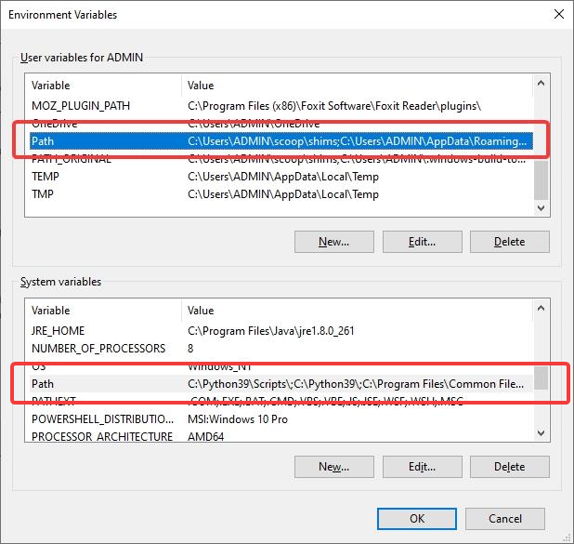

1. Copy lại đường dẫn tới folder của NodeJS và Yarn và paste lại vào Path

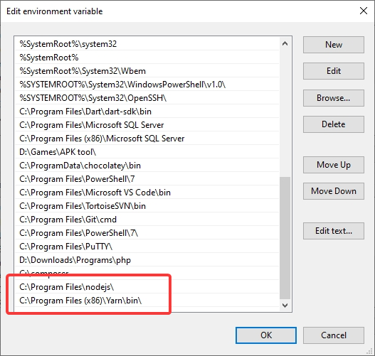

**Run Project**

After finished Installing all the necessary components

Open command promt or Powershell in your project folder or using VS Code terminal

And run Yarn serve to starts deploying web.

